Exp No:20Experiment to understand K-means clustering algorithm for
a given data set.
Code:
import numpy as np
import pandas as pd
import matplotlib.pyplot as plt
import seaborn as sns

df = pd.read_csv('Mall_Customers.csv.xls')
print(df.info())
print(df.head())
sns.pairplot(df)

features = df.iloc[:, [3, 4]].values

from sklearn.cluster import KMeans
model = KMeans(n_clusters=5)
model.fit(features)
# KMeans(n_clusters=5) <- notebook output, not code

Final = df.iloc[:, [3, 4]]
Final['label'] = model.predict(features)
print(Final.head())

sns.set_style("whitegrid")
sns.FacetGrid(Final, hue="label", height=8).map(plt.scatter, "Annual Income (k$)", "Spending Score (1-100)").add_legend();
plt.show()

features_el = df.iloc[:, [2, 3, 4]].values

from sklearn.cluster import KMeans
wcss = []
for i in range(1, 10):
model = KMeans(n_clusters=i)
model.fit(features_el)
wcss.append(model.inertia_)

plt.plot(range(1, 10), wcss)
output:
<class 'pandas.core.frame.DataFrame'>
RangeIndex: 200 entries, 0 to 199
Data columns (total 5 columns):
# Column Non-Null Count Dtype
--- ------ -------------- -----
0 CustomerID 200 non-null int64
1 Gender 200 non-null object
2 Age 200 non-null int64
3 Annual Income (k$) 200 non-null int64
4 Spending Score (1-100) 200 non-null int64
dtypes: int64(4), object(1)
memory usage: 7.9+ KB
None
CustomerID Gender Age Annual Income (k$) Spending Score (1-100)
0 1 Male 19 15 39
1 2 Male 21 15 81
2 3 Female 20 16 6
3 4 Female 23 16 77
4 5 Female 31 17 40
/tmp/ipykernel_8428/1581870528.py:20: SettingWithCopyWarning:
A value is trying to be set on a copy of a slice from a DataFrame.
Try using .loc[row_indexer,col_indexer] = value instead

See the caveats in the documentation: https://pandas.pydata.org/pandas-docs/stable/user_guide/indexing.html#returning-a-view-versus-a-copy
Final['label'] = model.predict(features)
Annual Income (k$) Spending Score (1-100) label
0 15 39 2
1 15 81 1
2 16 6 2
3 16 77 1
4 17 40 2
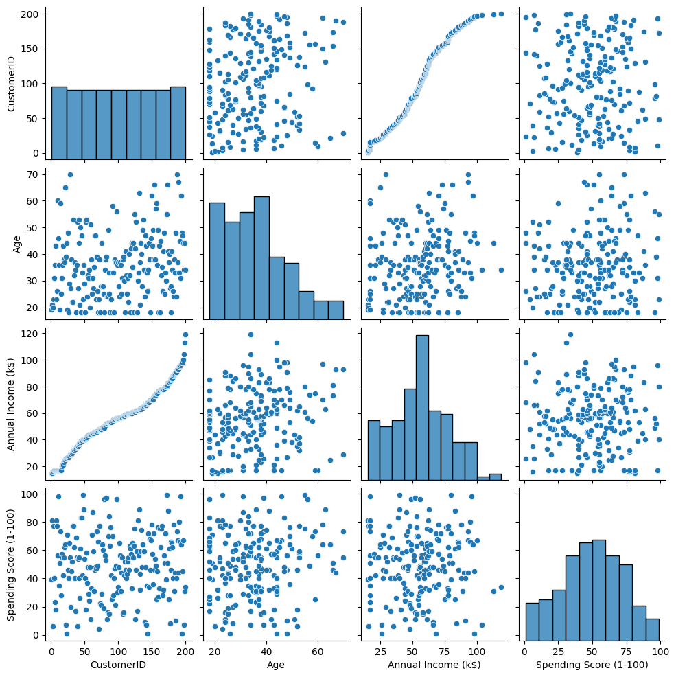
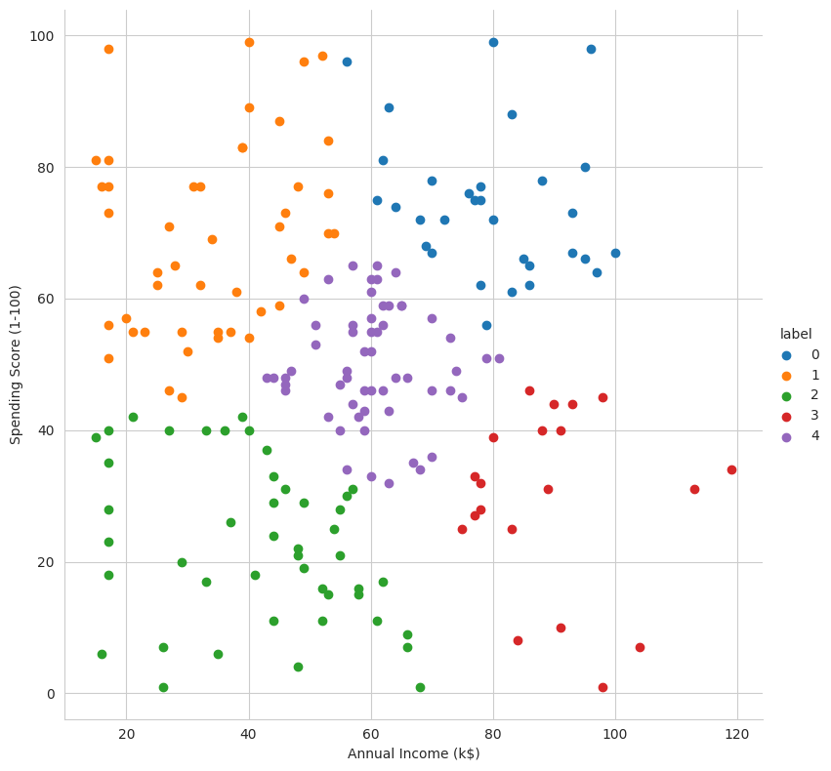
[<matplotlib.lines.Line2D at 0x7d64ccd45810>]
